OCR-style exam questions
Answer the questions by typing your answers into the red boxes.

What Caused the Cold War?
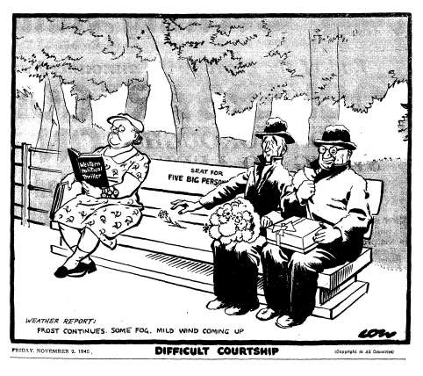
This cartoon by the British cartoonist David Low was published in the Evening Standard on 2 November 1945, after a breakdown in relations at the Conference of Ministers. To try to overcome the quarrel, Britain and the USA had offered the Soviet Union a twenty-five-year treaty of alliance.
The cartoon shows the three foreign ministers, Molotov (Soviet Union), Byrnes (USA) and Bevan (UK).. Molotov, dressed as a woman, is reading a book entitled: 'Western political thriller'.

1 Study the cartoon. What is the message of this cartoon? Use the details of the cartoon and your knowledge to explain your answer. [7]

2 Describe the different aims of the superpowers in the making of peace after the Second World War. [4]

3 Explain how resentment about the past helped to cause the Cold War. [8]

4 ‘The Cold War was primarily a clash of conflicting ideologies.’ How far do you agree with this statement? Explain your answer. [10]

