Blood Brothers - the Story

Blood Brothers is a story about a superstition – the curse of the separated twins.
This curse (made up by the author Willy Russell) states that when twins are secretly parted, if either twin learns that he was once a pair, both twins shall immediately die.

A Cursed Agreement
At the start of the story, the Narrator introduces the story of the Johnstone twins, “as like each other as two new pins” and how they died “never knowing that they shared one name till the day they died”. He invites you to judge for yourself how their mother – according to the legend “so cruel there’s a stone in place of her heart” – came to play her part.

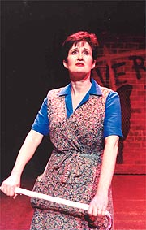
Blood Brothers begins and ends with Mrs Johnstone. Once a beautiful young woman, she sings about how she was duped by a smooth-talking man, who told her she was “like Marilyn Monroe”. They go dancing, get married, have lots of children – and then he leaves her, looking old before her time.
Mrs Johnstone struggles to cope. Her home is poor, and she lives from ‘the catalogue’ – “on the never never”. She finds it hard to say no, and is in constant money trouble. She is weak-willed, superstitious and easily bullied. Her children are wild and badly behaved – ‘The Welfare’ continually threaten to take them from her.

Things seem to be looking up when she gets a cleaning job for a Mrs Lyons – only for them to be shattered again when she finds she is expecting twins.
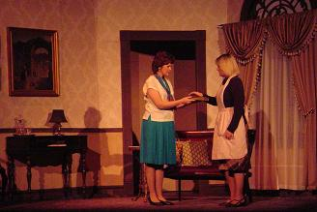
Although she is rich and middle-class, Mrs Lyons is just as sad as Mrs Johnstone, in her own way. Unable to have children, and with a husband who frequently works away, she is lonely and unfulfilled. When she hears that Mrs Johnstone is expecting twins, she persuades her to hand one over to her – to pretend that it is her own child.

Agreeing at first, Mrs Johnstone has second thoughts when the twins are born, but Mrs Lyons bullies her into giving her one of the twins – “We made an agreement, a bargain. You swore on the Bible…”
Mrs Johnstone thinks she will still see her lost son when she goes cleaning, but Mrs Lyons becomes increasingly jealous and eventually sacks her. And when Mrs Johnstone threatens to tell someone, she is silenced when Mrs Lyons tells her the curse of the separated twins – “You won’t tell anyone about this, Mrs Johnstone, because if you do, you will kill them”.
At this point, the Narrator lists a whole string of omens of disaster – shoes upon the table, the salt’s been spilled, someone broke the looking glass. The play has a sense of doom from this point, as events work themselves out to fulfil the prophecy – “Now you know the devil’s got your number. He’s gonna find you. You know he’s right behind you.”

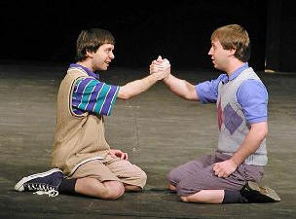
Children
The next time we meet the characters is when the twins are aged 7 – nearly eight. Mickey Johnstone, while playing Cowboys and Indians, wanders up the ‘posh end’ of the neighbourhood and bumps into Edward Lyons. Finding they share the same birthday, they become immediate friends. One day, they decide to become ‘blood brothers’. Mickey envies Edward his sweets and toys; Edward envies Mickey his naughty adventures and knowledge of swear-words. Both long to be ‘in the other’s shoes’.
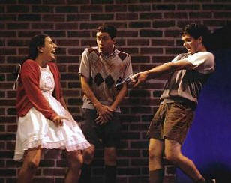
When they find out, both mothers try to stop the children meeting, but the bond is too strong, and the boys disobey their parents to meet each other, and a mutual friend, Linda.

Ominously, their favourite game is cops and robbers, and they have gangster-like pretend ‘shoot-outs’ – they get ‘shot’ and ‘die’, “but you know if you cross your fingers and if you count from one to ten, you can get up off the ground again. It really doesn’t matter the whole thing’s just a game”.
The idea of ‘class’ comes into many of Willy Russell’s plays, and there is a telling scene when the three land up in trouble with the police. Whereas Mickey is returned home with threats of court and prison, Edward is taken home with a smile and the reassurance that it was “just a prank … he’s a good lad”.
Mrs Lyons, increasingly mentally unstable, persuades her husband to move to the country. But then Mrs Johnstone, equally, is re-housed nearby on a new out-of-town council estate (where they only fight at weekends). Thus fate throws the two boys together again when they meet by chance, aged 14.

A visit to the pictures and a meeting with Linda re-unites the threesome, and this time they run away from the police! Both boys fancy Linda, but Edward is much too shy to tell her.

Depression…
The boys’ friendship, however, finds itself tested by fate, and class. Edward goes to university, returns to a successful career and becomes a local Councillor. Mickey gets a job he hates in a local factory, and he marries Linda because she gets pregnant.

But then there is a downturn in the economy, and Mickey loses his job. To Edward, not having to work seems rather fun, but Mickey tells him that he doesn’t know what he is talking about. The two part angrily. Instead, Mickey gets in with his criminal elder brother Sammy, and is persuaded to take part in a robbery in which the night watchman is shot. Mickey is sent to prison for 7 years.

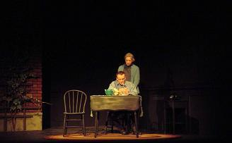
When he comes out, Mickey is a broken man, depressed, hopeless, and dependent on pills. Linda is reduced to despair … and turns to her influential friend, Councillor Edward Lyons, for help.

During this time, Linda becomes aware of the fun she has lost (“There’s a girl inside the women who’s waiting to get free. She’s washed a million dishes and she’s always making tea”) and she and Edward fall in love – “nothing cruel, nothing wrong, just two fools who know the rules but break them all, and grasp at half a chance to play their part in light romance”.

… and Disaster
At this point, Mrs Lyons tells Mickey about the relationship between Linda and Edward. Mickey – who has stopped taking the pills to try to rebuild his life with Linda – explodes: “There’s a man gone mad, lost his mind tonight … there’s a mad man running round and round” says the Narrator. Linda, terrified, runs to tell Mrs Johnstone, who sets off to find him…

And so the scene is set for the final disaster.

Edward Lyons is speaking in the Council Chamber when Mickey bursts in with a gun.
He is going to kill Edward for taking Linda from him, but he can’t bring himself to do it.

Armed police arrive .. and so does Mrs Johnstone:
“Mickey. Don’t shoot Eddie. He’s your brother. You had a twin brother. I couldn’t afford to keep both of you. His mother couldn’t have kids. I agreed to give one of you away!”

Mickey, who had been lapsing into despair, becomes uncontrollable with rage:
“Why didn’t you give me away! I could have been … him!”

He waves the gun at Edward to point at him.
As he does this, the gun goes off and kills Edward, and the police immediately shoot Mickey dead too.

The play ends with Mrs Johnstone left singing: ‘Tell me it’s not true’.
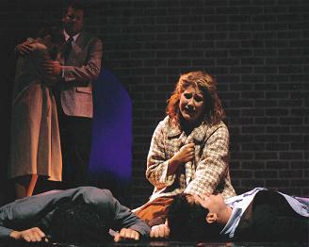

At the start of the play, the narrator invites the audience to judge Mrs Johnstone.
At the end of the play, he asks them a different question:
“And do we blame superstition for what came to pass?
Or could it be what we, the English, have come to know as ‘class’?”

